UBND HUYỆN TỨ KỲ
TRƯỜNG TIỂU HỌC QUANG PHỤC

MA TRẬN ĐỀ KIỂM TRA HỌC KỲ I - NĂM HỌC 2021 - 2022
MÔN TIẾNG ANH LỚP 5

Kĩ  năng | Nhiệm vụ đánh giá/  kiến thức cần đánh giá | Mức điểm |  |  |  | Tổng số  câu, điểm,  tỉ lệ %
 |  | M₁ | M₂ | M₃ | M₄
Listening | Question 1: Listen and match. | 4 câu  1đ |  |  |  | 12 câu  3 điểm  30%
 | Question 2: Listen and tick A, B or C. |  | 2 câu  0,5đ | 2 câu  0,5 đ
 | Question 3: Listen and tick the correct pictures. |  | 3 câu  0,75 đ | 1 câu  0,25 đ
Reading | Question 4: Look and write the correct words. | 2 câu  0,5 đ | 2 câu  0,5 đ |  |  | 16 câu  4 điểm  40%
 | Question 5: Read and tick True or False. | 1 câu  0,25 đ | 1 câu  0,25 đ | 2 câu  0,5 đ
 | Question 6: Read and number the sentences in the correct order. | 1 câu  0,25 đ | 1 câu  0,25 đ | 1 câu  0,25 đ | 1 câu  0,25 đ
 | Question 7: Look and read. Fill each gap with one word from the box. |  |  | 2 câu  0,5 đ | 2 câu  0,5 đ
Writing | Question 8: Order the words. | 2 câu  0,25đ | 1 câu  0,25đ | 1 câu  0,25 đ |  | 8 câu  2 điểm  20%
 | Question 9: Read and circle a, b or c. | 1 câu  0,25đ | 1 câu  0,25 đ | 1 câu  0,25 đ | 1 câu  0,25 đ
Speaking | Question 1: Getting to know each other. | 1 câu  0,25đ |  |  |  | 4 câu  1 điểm  10%
 | Question 2: Talking about familiar object. | 1 câu  0,25đ | 1 câu  0,25đ
 | Question 3: Describe a picture. |  |  | 1 câu  0,25đ
Tổng số câu:  Tổng điểm:  Tỉ lệ % |  | 13  3,25đ  32,5% | 12  3đ  30% | 11  2,75đ  27,5% | 4  1 đ  10% | 40 câu  10^{đ}  100%

PHÒNG GD & ĐT HUYỆN TỨ KỲ  TRƯỜNG TIỂU HỌC QUANG PHỤC | BÀI KIỂM TRA CUỐI HỌC KÌ I NĂM HỌC 2021-2022  MÔN: TIẾNG ANH-LỚP 5  THỜI GIAN: 40 PHÚT  (Không kể thời gian giao đề)

Full name: ..................................................................................... Class: .......................

Marks | Listening |  |  | Reading |  |  |  | Writing |  | Speak  ing | Total
 | Q.1 | Q.2 | Q.3 | Q.4 | Q.5 | Q.6 | Q.7 | Q.8 | Q.9 | Q.10
Comment:
PART I: LISTENING (8 minutes)
Question 1. Listen and match. There is one example (0). (1 point)
Example: 0. E.
A. | B. | C. | D.

1.………… 2…………. 3………… 4…………..
Question 2. Listen and tick A, B or C. There is one example. (1 point)
Example: A. I usually have a big B. I usually go fishing C. I usually watch
breakfast before I go to school. after school. TV in the afternoon.
1. A. I usually do morning B. I usually go to school C. I usually do my
exercise before breakfast. after breakfast. homework after school.
2. A. I go to the library B. I go to the library with C. I go to the library
once a week. my friends. because I like reading.
3. A. Because I’m surfing B. Because I’m looking for C. Because I surf the Internet
the Internet. some information. three times a week.
4. A. I usually study with B. I usually study everyday. C. I usually study English
a partner. songs.
Question 3. Listen and tick the correct pictures. There is 1 example. (1 point)
Example: How does she practise English?
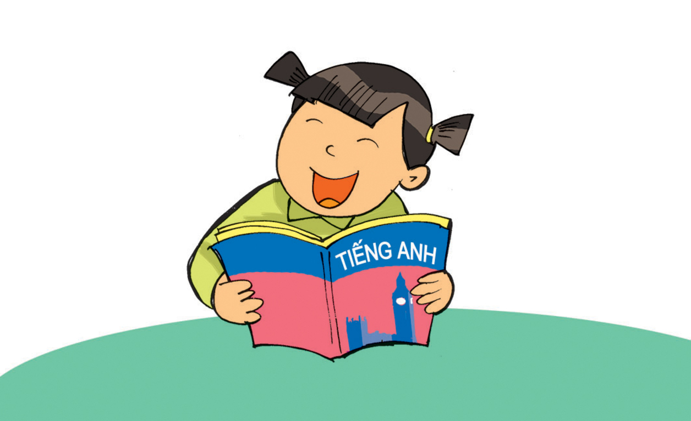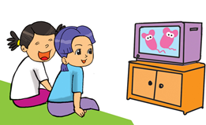
A. B. C.
1. How do you practise English?
A. 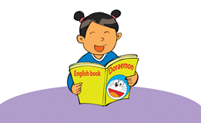 B. 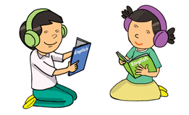 C. 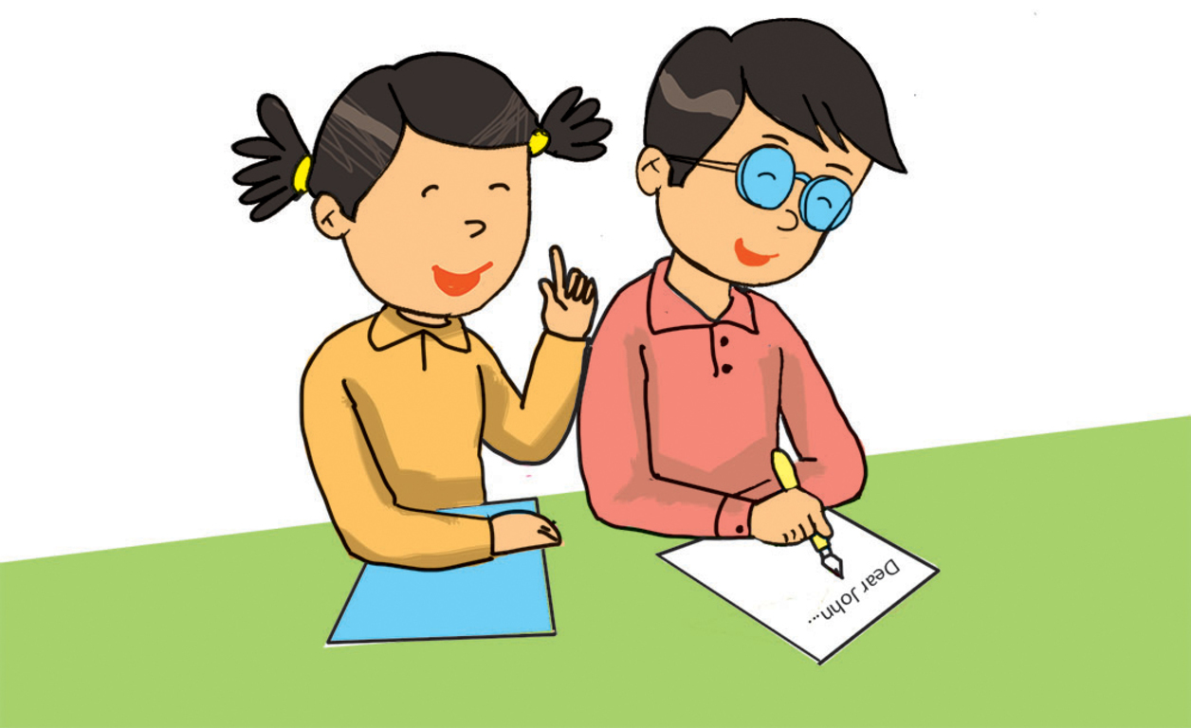
2. How does she practise English?
A. 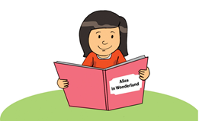 B. C.
3. Why does she learn English?
A. B. C. 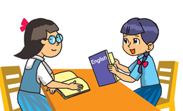
4. Why does she learn English?
A. B. C.

PART II: READING (12 minutes)
Question 4. Look and write the correct words. There is one example. (1 point)
motorbike train underground ship plane
Example: It is long and it can go on the ground. train
1. It can fly in the sky. …………………………
2. It can go in the sea. …………………………
3. It is long. It can go under the ground. …………………………
4. You must wear a helmet when you ride it. …………………………
Question 5. Read and tick (V) True or False. There is one example (0). (1 point)
Hoa likes English very much. At school, she has English four times a week. She often speaks English with her classmates. Sometimes, she talks with her foreign friend, Akiko. They are happy because they can understand each other. Hoa usually reads English comic books in her free time. At home, she practises listening by watching cartoons on TV. Hoa studies English hard because she wants to be an English teacher.
 | True | False
0. Hoa’s favourite subject is English.
1. She has English every day.
2. Akiko can understand Hoa’s English.
3. Hoa usually reads comic books to practise listening.
4. Hoa needs English for her future job.
Question 6. Read and number the sentences in the correct order. The conversation begins
with 0. (1 point)
……. A Binh: Great! I’ll buy and read it tomorrow!
……. B Hien: Who is the main character?
…0… C Binh: What are you reading, Hien?
…….. D Hien: I’m reading The Legend of The Watermelon. The story’s very interesting.
…….. E Binh: It’s Mai An Tiem. He’s a brave and clever man.
Question 7. Look and read. Fill each gap with one word from the box. There is one example (0). (1 point)
computer | morning | sunbathe | badminton | Ha Long Bay | sandcastles

Hello, I’m Phong. I’ll go to (0) Ha Long Bay with my family next weekend. It’ll be a lot of fun. In the (1) ……………………… , I think my parents will swim in the sea. They love swimming! My brother and I will build (2) ………………………….. on the beach. In the afternoon, my mum and dad will (3) ………………………... My brother and I will play (4) ………………………… by the sea. Then we’ll have dinner on Tuan Chau Island. Seafood, I hope!
PART III: WRITING (10 Minutes)
Question 8. Order the words. There is one example. (1 point)
Example: | 0. had / yesterday / four / he / lessons  => He had four lessons yesterday.
1. you/ What/ going/ Day? / do/ are/ Sports/ to/ on
=> What ………………………………………………………………………………………?
2. have / week. / I / twice / English / a
=> I ……………………………………………………………………………………………..
3. always/ after/ homework/ I/ do/ school. / my
=> I ……………………………………………………………………………………………..
4. the/ do/ when/ were/ peacocks/ What/ you/ there ?/ did
=> What ………………………………………………………………………………………...?
Question 9. Read and circle a, b or c. There is one example. (1 point)
0. I often ………………… TV after dinner.
a. watch b. watches c. watching
1. I live in Flat 8 on the second floor …………….. Ha Noi Tower.
a. on b. in c. of
2. Phong and I ………….…….. going to play volleyball next Sunday.
a. am b. are c. is
3. How do you practise ………………… English?
a. speaking b. speak c. speaks
4. Nam ……………… to Mai’s birthday party yesterday.
a. go b. went c. goes

PART IV: SPEAKING (10 minutes)
Speaking (1 point)

PART IV: SPEAKING (10 minutes)
Speaking (1 point)
Question1: Get to know each other. (0,25 point)
The examiner asks 3 questions below:
1. What’s your full name?
2. What is the date today?
Question 2: Talk about familiar topics. (0,5 point)
The test taker is given a carton box in which there is a set of topics. The examiner tells the test taker to pick one topic into the box and talk for two or three minutes.
(“Please open the box and take one topic.”)
The examiner requires the examinee to talk about his/her daily activities.
Question3: Describing the picture. (0,25 point)
The examiner says, “Now you have 30 seconds to look at this drawing.
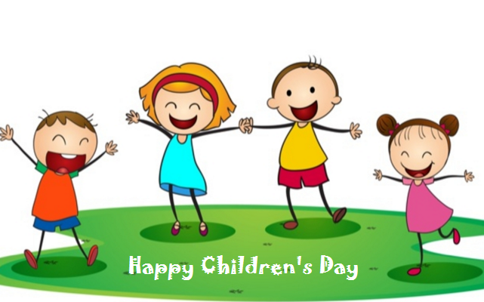
The examiner asks 2 questions below:
1. How many people are there in the picture?
2. What are you going to do on Children’s Day?
PART I: LISTENING (8 minutes)

AUDIO SCRIPT

Question 1: Listen and match.
0. I’m reading The Story of Tam and Cam.
1. He’s reading The Story of Mai An Tiem.
2. She’s reading Aladdin and the Magic Lamp.
3.I’m reading The Fox and the Crow.
4. He’s reading Snow White and the Seven Dwarfs.
Question 2. Listen and tick A, B or C.
0. What do you usually do after school?
1. When do you do your homework?
2. How often do you go to the library?
3. Why are you surfing the internet?
4. Who do you usually study with?
Question 3. Listen and tick the correct pictures.
0. (B): How do you practise listening English, Mai?
(G): I watch English cartoons on TV.
1. (G): How do you practise reading English?
(B): I read English comic books.
2. (B): How do you practice speaking English?
(G): I speak English to my foreign friends every day.
3. (B): Why do you learn English?
(G): Because I want to sing English songs.
4. (G): Why do you learn English?
(B): Because I want to write emails to my pen friends.

PHÒNG GD & ĐT HUYỆN TỨ KỲ  TRƯỜNG TIỂU HỌC QUANG PHỤC | HƯỚNG DẪN CHẤM BÀI KIỂM TRA HKI  NĂM HỌC 2021 - 2022  MÔN TIẾNG ANH LỚP 5
PART I: LISTENING (3 points)
Question 1: Listen and match. (1 point)
Answer key: (0,25p for each correct answer)
1. C 2. A 3. B 4. D
Question 2. Listen and tick A, B or C. (1 point)
Answer key: (0,25p for each correct answer)
1. C 2. A 3. B 4. A
Question 3. Listen and tick the correct pictures. (1 point)
Answer key: (0,25p for each correct answer)
1. A 2. C 3. A 4. B
PART II. READING (4 points)
Question 4. Look and write the correct words. (1 point)
Answer key: (0,25p for each correct answer)
1. plane 2. ship 3. underground 4. motorbike
Question 5. Read and tick (V) True or False. (1 point)
Answer key: (0,25p for each correct answer)
1. False 2. True 3. False 4. True
Question 6. Read and number the sentences in the correct order. (1 point)
Answer key: (0,25p for each correct answer)
1. D 2. B 3. E 4. A
Question 7. Look and read. Fill each gap with one word from the box. (1 point)
Answer key: (0,25p for each correct answer)
1. morning 2. sandcastles 3. sunbathe 4. badminton
PART III. WRITING (2 points)
Question 8. Order the words. (1 point)
Answer key: (0,25p for each correct answer)
1. What are you going to do on Sports Day?
2. I have English twice a week.
3. I always do my homework after school.
4. What did the peacocks do when you were there?
Question 9. Read and circle a, b or c. (1 point)
Answer key: (0,25p for each correct answer)
1. c 2. b 3. a 4.b

