School: .......................................  Full name: .......................................  Class:................................. | PHONICS - SMART TEST  LEVEL 2 - TERM 1 – Final Test  School year: 2021-2022  Time: 40 minutes
MARKS | LISTENING |  | READING AND WRITING |  | SPEAKING | TOTAL | COMMENTS
 | P1 | P2 | P1 | P2
SECTION 1 – LISTENING (4pts)
Part I. Listen and number the pictures. There is one example.(2 pts).
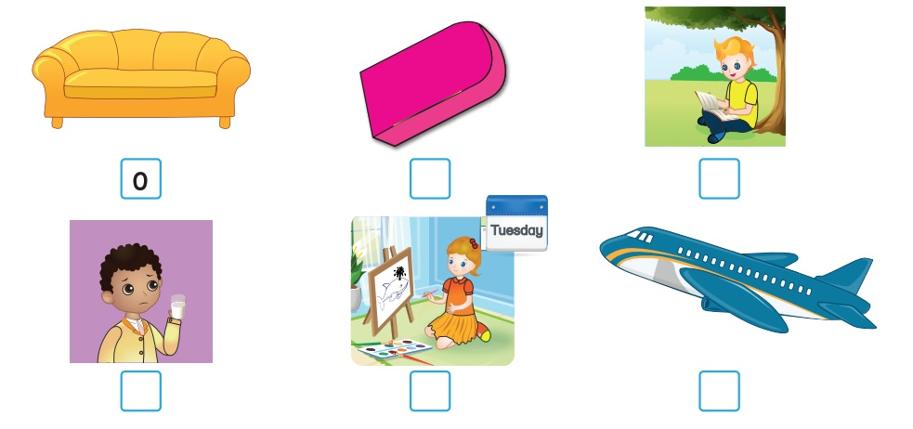

Part II. Listen and tick () the box. There is one example. (2 pts)
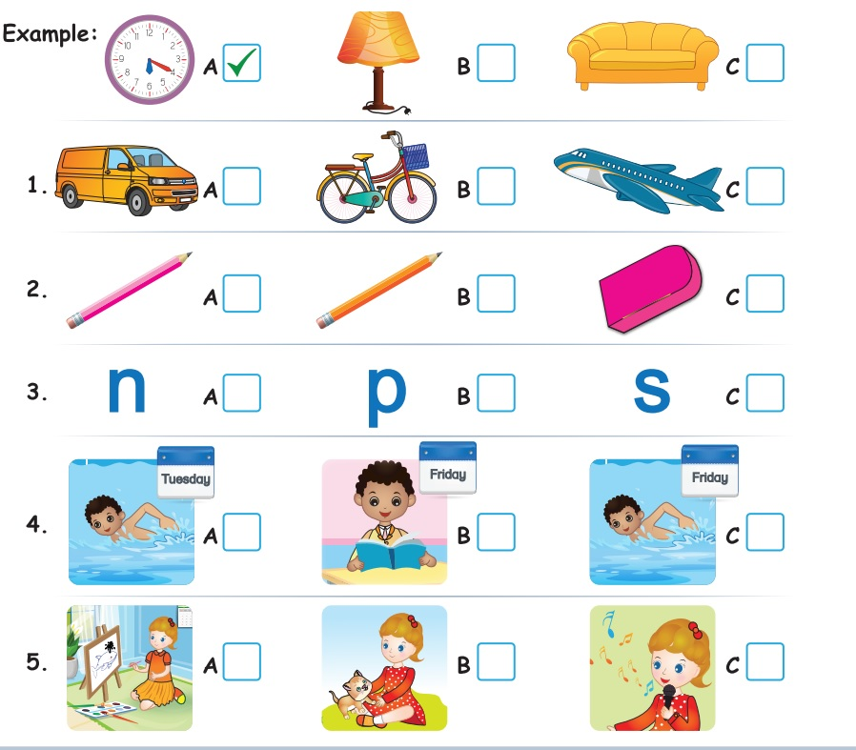
pink
SECTION 2 – READING AND WRITING (5 pts)
Part I. Look and read. Put a tick () or a cross () in the box.
There are two examples. (2,5 pts)
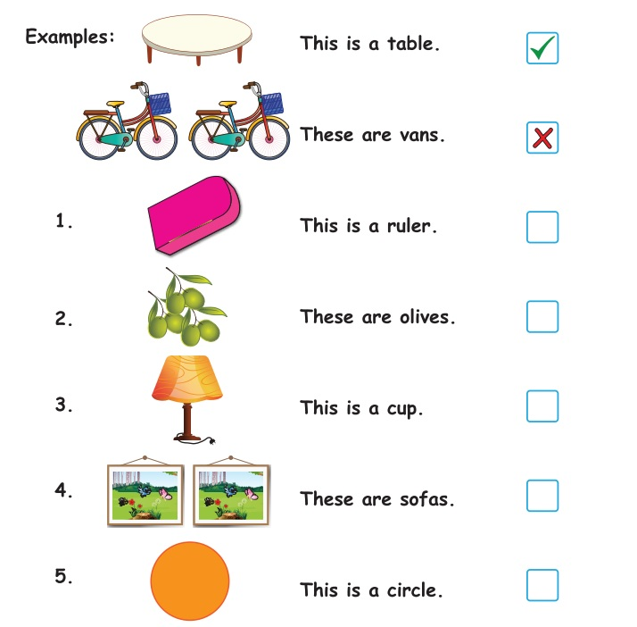
Part II. Look at the pictures. Look at the letters.
Write the words. There is one example. (2,5 pts)
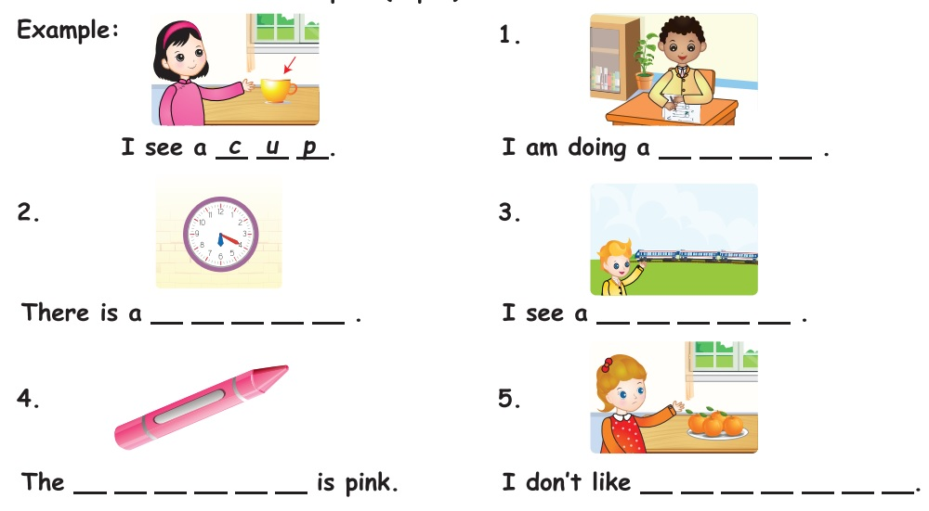
SECTION 3- SPEAKING (1Pt)
- Greetings.
- Now, look at the picture. Listen and answer.

