MA TRẬN ĐỀ KIỂM TRA HỌC KỲ I - NĂM HỌC 2021 - 2022
MÔN TIẾNG ANH LỚP 4

Kĩ  năng | Nhiệm vụ đánh giá/  kiến thức cần đánh giá | Mức điểm |  |  |  | Tổng số  câu, điểm,  tỉ lệ %
 |  | M₁ | M₂ | M₃ | M₄
Listening | Question 1: Listen and tick. | 5 câu  1,25đ |  |  |  | 15 câu  3,75 điểm  37,5 %
 | Question 2: Listen and tick ( ) or cross (x) |  | 3 câu  0,75đ | 2 câu  0,5 đ
 | Question 3: Listen circle the correct answers. |  | 3 câu  0,75 đ | 1 câu  0,25 đ | 1 câu  0,25đ
Reading | Question 4: Read and write YES or NO. | 3 câu  0,75 đ | 2 câu  0,5 đ |  |  | 10 câu  2,5 điểm  25 %
 | Question 5: Read and tick ( ) or cross (x) |  | 2 câu  0,5đ | 2 câu  0,5 đ | 1 câu  0,25 đ
Writing | Question 6: Look and write. | 3 câu  0,75đ | 1 câu  0,25đ | 1 câu  0,25 đ |  | 11 câu  2,75 điểm  27,5%
 | Question 7: Put the words in order. | 2 câu  0,5đ | 2 câu  0,5đ | 1 câu  0,25 đ | 1 câu  0,25đ
Speaking | Question 1: Getting to know each other. | 1 câu  0,25đ |  |  |  | 4 câu  1 điểm  10%
 | Question 2: Talking about a familiar object. |  | 2 câu  0,5 đ
 | Question 3: Describe a picture. |  |  | 1 câu  0,25 đ
Tổng số câu:  Tổng điểm:  Tỉ lệ % |  | 14  3,5 đ  35% | 15  3,75đ  37,5% | 8  2 đ  20% | 3  0,75đ  7,5% | 40 câu  10^{đ}  100%

PHÒNG GD & ĐT HUYỆN TỨ KỲ  TRƯỜNG TIỂU HỌC QUANG PHỤC | BÀI KIỂM TRA CUỐI HỌC KÌ I NĂM HỌC 2021-2022  MÔN: TIẾNG ANH-LỚP 4  THỜI GIAN: 40 PHÚT  (Không kể thời gian giao đề)

Full name: ............................................................................................ Class: ..........................

Marks | Listening |  |  | Reading |  | Writing |  | Speaking | Total
 | Q.1 | Q.2 | Q.3 | Q.4 | Q.5 | Q.6 | Q.7 | Q.8
Comment:

PART I: LISTENING (10 minutes)
Question 1. Listen and tick . There is one example. (1,25 points)
0. Example: A. B.
1. 2.
A. 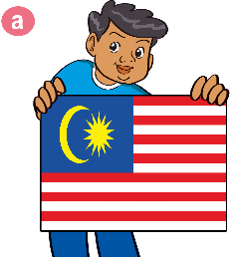 B. A. B.
3. 4.
A. B. A. B. 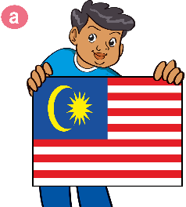
5. A. B.
Question 2. Listen and tick or cross . There are two examples. (1,25 points)
Examples: 0. A. B. 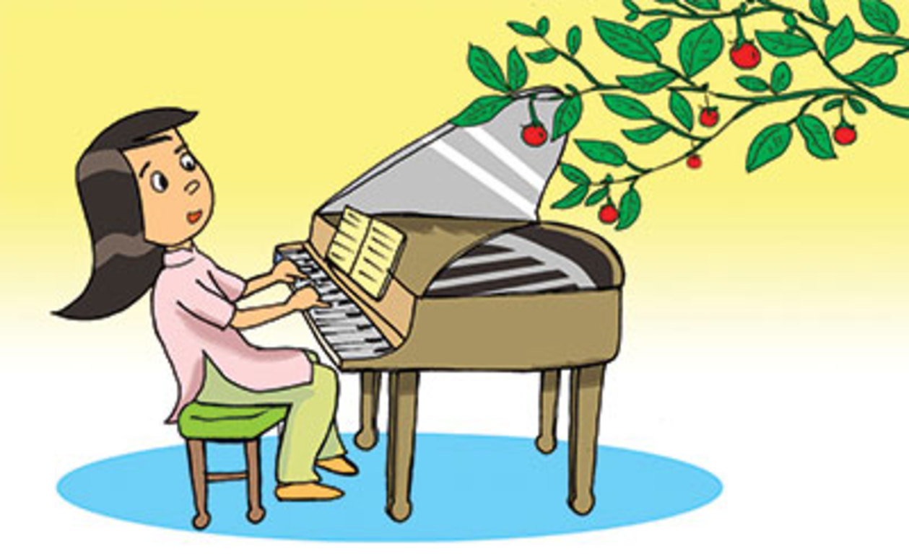
1. 2. 3. 4. 5.

Question 3. Listen and circle the correct answers. There is one example. (1,25 points)
Example: A. On the beach. B. At home. C. At the zoo.
1. | A. On Tuesdays and Wednesdays. | B. On Tuesdays and Thursdays. | C. On Tuesdays and Fridays.
2. | A. Watching TV. | B. Listening to music. | C. Cooking.
3. | A. They’re playing volleyball. | B. They’re playing tennis. | C. They’re playing football.
4. | A. IT, Art and Music. | B. IT, Art and Maths. | C. IT, Art and Science.
5. | A. In South Street. | B. In South Village. | C. In South District.
PART II. READING (10 minutes)
Question 4. Read and write YES or NO. There is an example. (1,25 points)
Hello, I’m Mai from Oxford Primary School. It’s Monday today. We have Art and Science today. I’m in the Art class now. The girls are drawing cats. The boys are making paper planes. It was Sunday yesterday. I was at home. In the morning, I painted a picture. In the afternoon, I played table tennis. In the evening, I watched TV.
Example: 0. Mai is a pupil at Oxford Primary School. YES
1. She has Art and Science on Mondays. _____
2. All pupils are drawing cats in the Art class now. _____
3. Yesterday Mai was at school. _____
4. She painted a picture on Sunday morning. _____
5. She played table tennis on Sunday evening. _____

Question 5. Read and tick or cross . There are two examples. (1,25 points)
Examples: 0. A. Tony is playing chess. B. Linda is skating.
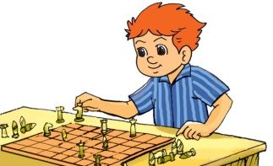
1. They’re painting a picture. 2. He’s making a paper boat. 3. He’s writing a dictation.
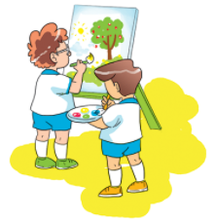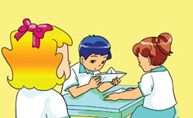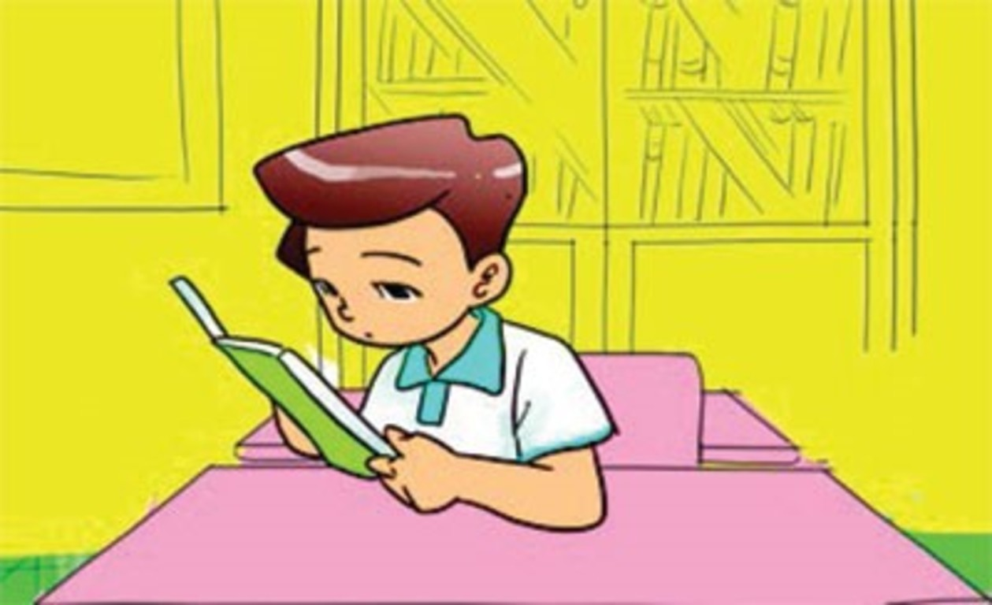
4. He’s playing badminton. 5. They’re watching videos. 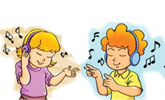

PART III: WRITING (10 minutes)
Question 6. Look and write. There is one example. (1,25 points)
Examples: mrahc → M a r c h

1. speetmreb → S _ _ _ _ _ _ _ _ 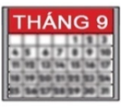 2. asutgu → A _ _ _ _ _ 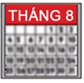
3. stihx → the _ _ _ _ _ of May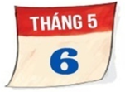 4. wftethl→ the _ _ _ _ _ _ of April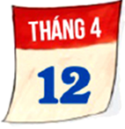

5. nhinteneet → the _ _ _ _ _ _ _ _ _ _ of July 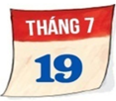

Question 7. Put the words in order. (1,5 points)
1. is/ book. / Hoa/ reading/ a
=> Hoa …………………………………………………………………………………....
2. subjects/ you/ What/ today? / do/ have
=> What …………………………………………………………………………………..?
3. likes/ My / much. / mother/ cooking/ very
=> My ……………………………………………………………………………………...
4. His/ in/ Village. / school/ is/ Bat Trang
=> His ……………………………………………………………………………………..
5. December. / My/ is/ the/birthday/ on/ eleventh/ of/ friend’s
=> My ……………………………………………………………………………………..
6. I/ in/ visit/ grandparents/ afternoon. / the/ my
=> I ..………………………………………………………………………………………

PART IV: SPEAKING (10 minutes)
Speaking (1 point)

PART IV: SPEAKING (10 minutes)
Speaking (1 point)
Greeting and test taker’s name check.
The examiner says “My name is…It’s nice to talk to you today.”
Question 1: Getting to know each other. (0,25 point)
The examiner asks 3 questions below:
1. What’s your name?
2. Where are you from?
3. What can you do?
Question 2: Talking about a subject. (0,5 point)
The test taker is given a carton box in which there is a set of school subjects. The examiner tells the test taker to pick one thing into the box and answer the following questions. (“Please open the box and take one thing.”)
Eg: What is in your hand?
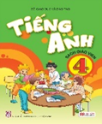
1. Tell me some subjects that you know?
2. Do you like Maths?
3. What subjects do you have on Fridays?
Question 3: Describing the picture. (0,25 point)
The examiner says, “Now you have 30 seconds to look at this drawing.”
The examiner asks 2 questions below:
1. What can he do?
2. How often do you go swimming?
PART I: LISTENING (10 minutes)
AUDIO SCRIPT
Question 1. Listen and tick . There is one example.
0. She’s from Viet Nam.
1. He’s from Viet Nam.
2. I’m from England.
3. My friend is from Japan.
4. He’s from Malaysia.
5. They’re from Australian.
Question 2. Listen and tick or cross . There are two examples.
0. a, What do you do in the morning? - I play football.
b, What do you do in the evening? - I watch TV.
1. (G): Do we have English today?
(B): No, we have it on Tuesday.
2. (G): Do you go swimming on Sundays?
(B): No, I visit my grandparents.
3. (B): What do you do in the afternoon?
(G): I do my homework.
4. (B): Do you help your parents at the weekend, Mary?
(G): Yes, I do. I clean the rooms.
5. (B): I play football with my friends on Sundays.
(G): Oh, that’s nice.
Question 3. Listen and circle the correct answers. There is one example.
0. Where were you yesterday? - I was on the beach.
1. When do you have Maths? - I have it on Tuesdays and Thursdays.
2. What’s your hobby? - I like cooking.
3. What’re they doing? - They’re playing volleyball.
4. What subjects do you have on Thursdays? - IT, Art and Science.
5. Where’s her school? - It’s in South Village.
PHÒNG GD & ĐT HUYỆN TỨ KỲ  TRƯỜNG TIỂU HỌC QUANG PHỤC | HƯỚNG DẪN CHẤM BÀI KIỂM TRA HKI  NĂM HỌC 2021 - 2022  MÔN TIẾNG ANH LỚP 4
PART I: LISTENING (3,75 points)
Question 1: Listen and tick. (1,25 points)
Answer key: (0,25p for each correct answer)
1. B 2. B 3. A 4. B 5. A
Question 2. Listen and tick or cross . (1,25 points)
Answer key: (0,25p for each correct answer)
1. 2. 3. 4. 5.
Question 3. Listen and circle the correct answers. (1,25 points)
Answer key: (0,25p for each correct answer)
1. B 2. C 3. A 4. C 5. B
PART II. READING (2,5 points)
Question 4. Read and write YES or NO. (1,25 points)
Answer key: (0,25p for each correct answer)
1. YES 2. NO 3. NO 4. YES 5. NO
Question 5. Read and tick or cross . (1,25 points)
Answer key: (0,25p for each correct answer)
1. 2. 3. 4. 5.
PART III. WRITING (2,75 points)
Question 6. Look and write. (1,25 points)
Answer key: (0,25p for each correct answer)
1. September 2. August 3. sixth 4. twelfth 5. nineteenth
Question 7. Put the words in order. (1,5 points)
Answer key: (0,25p for each correct answer)
1. Hoa is reading a book.
2. What subjects do you have today?
3. My mother likes cooking very much.
4. His school is in Bat Trang Village.
5. My friend’s birthday is on the eleventh of December.
6. I visit my grandparents in the afternoon.

