School: .......................................  Full name: .......................................  Class:................................. | PHONICS - SMART TEST  LEVEL 1 - TERM 1 – Final Test  School year: 2021-2022  Time: 40 minutes
MARKS | LISTENING |  | READING AND WRITING |  | SPEAKING | TOTAL | COMMENTS
 | P1 | P2 | P1 | P2
SECTION 1 – LISTENING (4 pts)
Part I. Listen and tick () the box. There is one example. (2 pts)
0. |  | A | 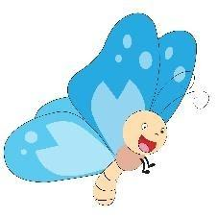 | B |  | C
1. |  | A | 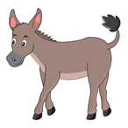 | B |  | C
2. |  | A |  | B |  | C
3. |  | A |  | B |  | C
4. |  | A |  | B |  | C
5. |  | A | 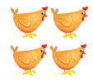 | B | 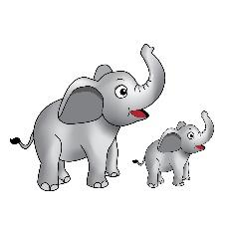 | C

Part II. Listen and choose Yes or No. There is one example. (2pts)
 |  | YES / NO |  |  | YES / NO
 |  | YES / NO |  | 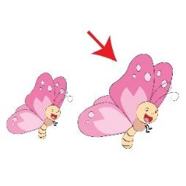 | YES / NO
 |  | YES / NO |  | 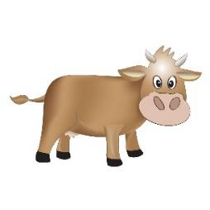 | YES / NO
SECTION 2 – READING AND WRITING (5 pts)
Part I. Look and read. Put a tick () or a cross () in the box.
There are two examples. (2,5 pts)
It is a butterfly.
It is an egg.
It is a donkey.
It is a cow.
It is yellow.
It is a bear.
It is a frog.
Part II. Look at the pictures. Look at the letters.
Write the words. There is one example. (2,5 pts)

0. |  | b e a r | 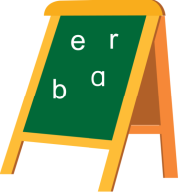 |  |  | _ _ _ | 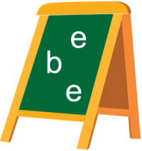
 |  | _ _ _ | 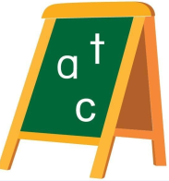 |  |  | _ _ _ _ | 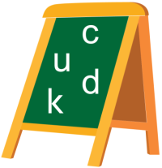
 |  | _ _ _ |  |  |  | _ _ _ _ _ _ _ _ | 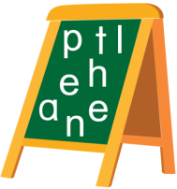
SECTION 3- SPEAKING (1Pt)
- Let’s greet and introduce. (0,5pt)
- Look at the picture. Listen and answer. (0,5pt)
How many…………….?
