School:…………………………………….  Full name: ...............................................  Class: ...................................................... | THE 1ST TERM TEST  Subject: English 3  School year: 2021-2022  Time: 40 minutes
MARKS | LISTENING |  |  | READING AND WRITING |  |  | SPEAKING | TOTAL | COMMENTS
 | T 1 | T 2 | T 3 | T 1 | T 2 | T 3
I. LISTENING (4,5 points)
Task 1. Listen and tick . There is one example. (1,5 points)
Example:
 | A. | B.

1. | A. B.
2. | A. B.
3. | A. B.
4. | A. B.
5. | A. B.
Task 2. Listen and tick or cross . There are two examples. (1,5 points)
Examples: |  | 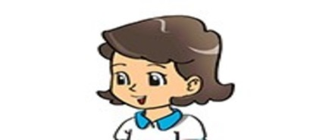
 | A. | B.

1. | 2. | 3.
4. | 5.
Task 3. Listen and number the pictures. The first picture is done for you. (1,5 points)
Example: | 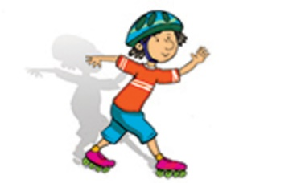
 | A.

B. | C. | D.
E. | F.
II. READING AND WRITING (4,5 points)
Task 1. Look and write. There is one example. (1,5 points)
Example: | iehn → H_ _ _  iehn → Hien

1. hlole→  h_ _ _ _ |  | 2. fotoblla →  f_ _ _ _ _ _ _
3. hankts→  t_ _ _ _ _ |  | 4. dnuorgyalp→  p_ _ _ _ _ _ _ _ _
5. ouy→
y_ _

Task 2. Look and read. Tick or cross the box. There are two examples. (1,5 points)
 | Sit down! | Stand up!
Examples: | 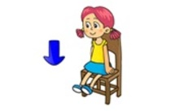
 | A. | B.

 | 1.  Stand up, please! | 2.  Come here, please!
 | 3.  Open your book, please! | 4.  May I come in?
5.
May I write my name here?

Task 3. Read and complete. There is one example. (1,5 points)
Hi | thanks | fine | you | how | hello

Quan: (0) Hi, Tony.
Tony: (1) _________, Quan and Phong.
Quan: (2) __________ are you?
Tony: I'm (3) _________, thanks. And you?
Quan: I'm fine. Thank (4) _________.
Tony: And how are you, Phong?
Phong: Fine, (5) _________.

III. SPEAKING (1 point)
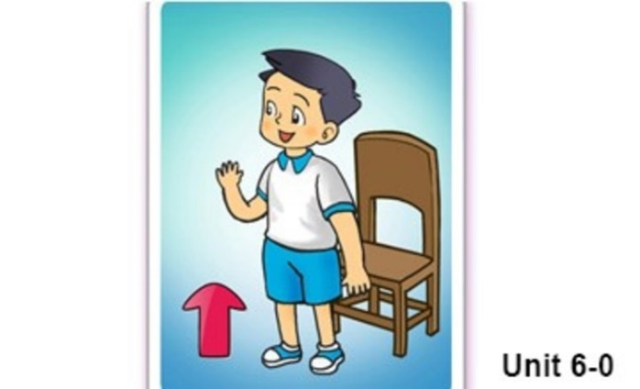 | 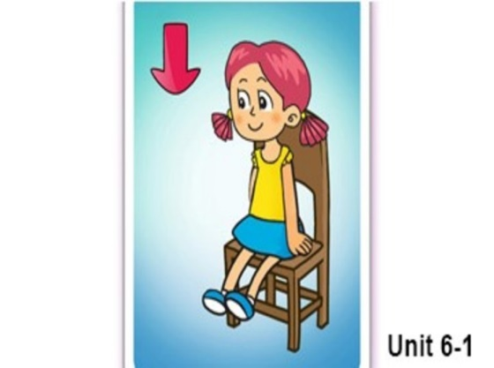
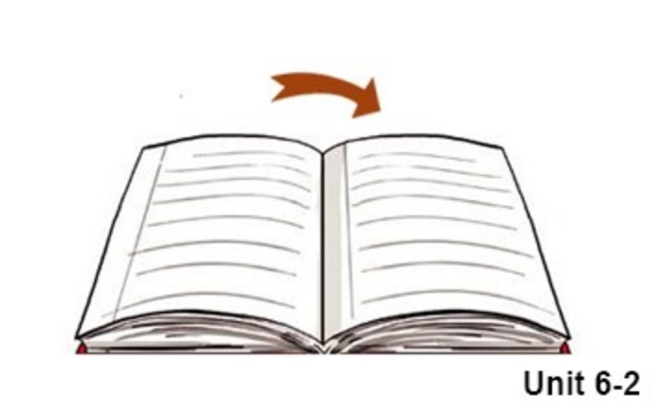 | 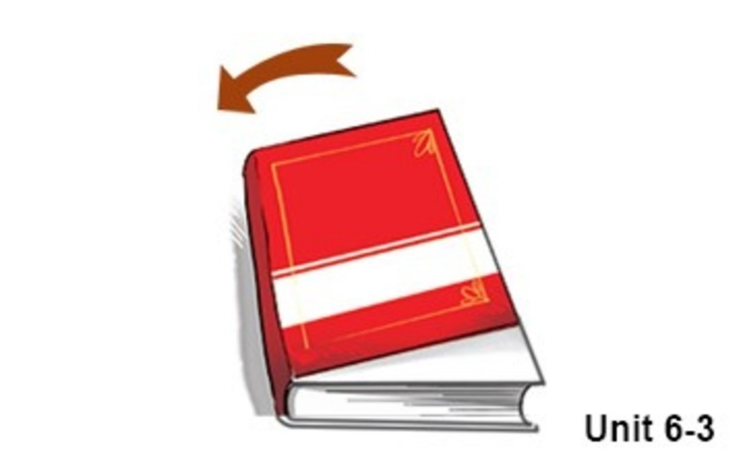
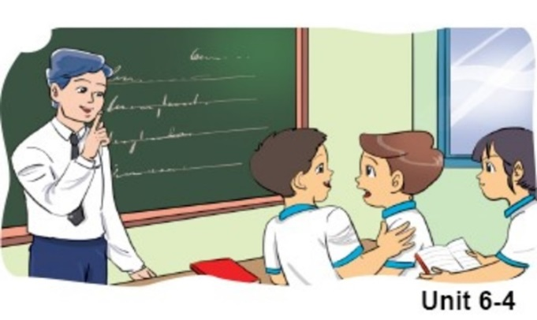 | 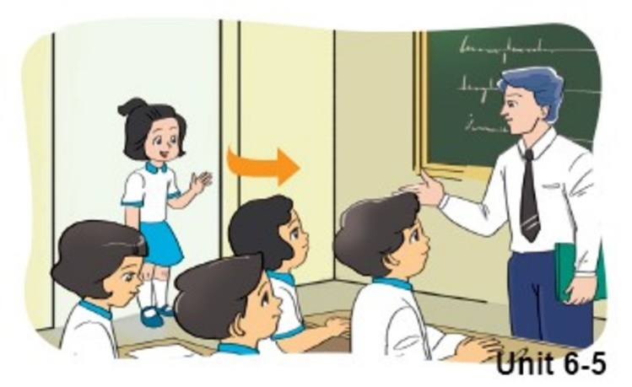
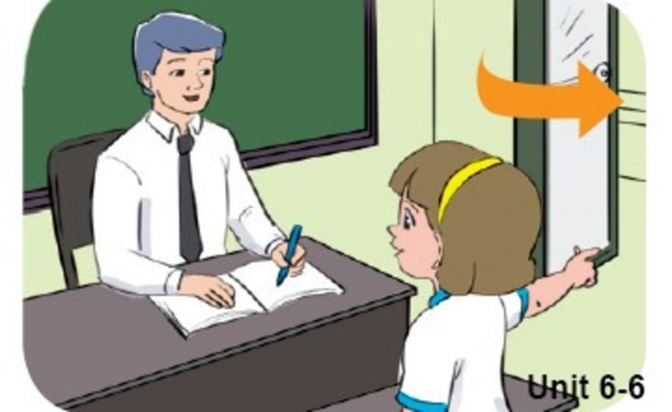 | 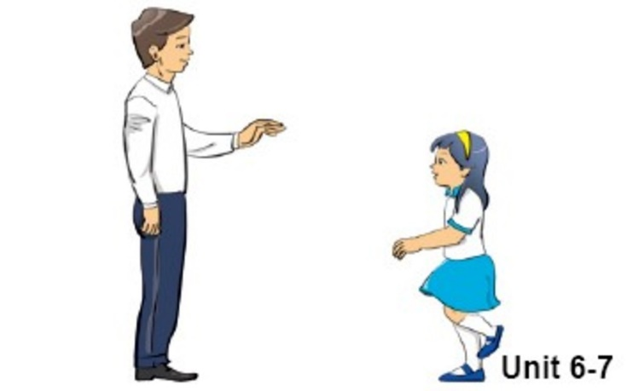
*****The end*****

